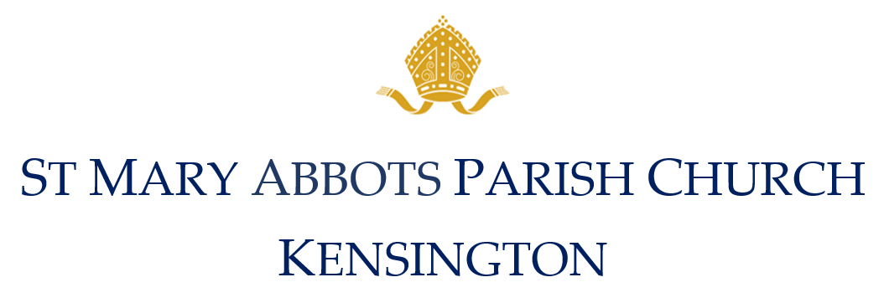

FEES FOR EXTERNAL ORGANISATION’S
SERVICES AND EVENTS 2020

Hire of the Church building for external organisations in evening: £900.00
Hire of the Church Building for external organisation during the daytime: £750.00

This block fee includes 1 hours rehearsal time on the day of the service.

A non refundable deposit will be required to confirm the booking £200.00
Full payment is required one month before the event

ADDITIONAL FEES

MUSIC FEES:
All music must be agreed with the Director of Music, Mark Uglow, who will help you with any musical requirements for the service or event. Mark Uglow 07973 418 826 or uglowmark@yahoo.co.uk.

External Choir
Service with choir or soloists - inc. consultation & rehearsal of up to 60 mins £225.00
Additional rehearsals: in the morning £50.00
In the evening £100.00
Service without singers - no prior consultation or rehearsal £175.00

Church Choir
Professional choir per singer, minimum 4 singers. £110.00
Soloists – any singer who performs a solo is paid £175.00

Organist / Organ
Provision of organist or use of organ £175.00
If you would prefer to use your own organist they must be approved by the Director of Music to protect the instrument.

If you would like any extra instrumentalist please talk to Mark Uglow directly

AUDIO 7 VIDEO RECORDING
The dioceses requires us to charge a flat fee of £100 to cover any professional and non-professional photography or recording in the in church, including with a mobile telephone.

If we are providing a choir or performers and additional 50% of all music fees will be required and passed on to the performers.

FLOWERS
Whether you want professional flower arrangers or the church team to assist, contact the Vicar’s PA, Leonora Service on 020 3479 4731 or pa@smaw8.org who can put you in touch with the appropriate person.

