IN OUR PRAYERS THIS HOLY WEEK

We pray for all victims of terrorism, war and violence, and natural disaster,

all refugees and those driven from home to escape poverty and famine.

We pray for those to be Baptised at Easter

ESIN CELEBI : JOHANNA HELBERSTEIN

JOHANN HELBERSTEIN : NAZANIN KARVAR

JAEYUN PARK : SHAFER SPRUCE

We pray for all those preparing for Confirmation at this time,

members of our Junior and our Adult Groups

Please pray for the sick and those in distress, especially

FREDDY BIRCHER : RHEA BROWN : JOHN C

JEAN CARR-GOMM : JEANETTE CLOW : LORENA DE LA TORRE

SICILLE KOTELAWALA : GILL LONGVILLE : JAMIE MARSDEN

ISABEL MILNER : ANNE PEERLESS : MARK REDMAN

CHARLOTTE REEVE : LARRY ROLLAND : JUNE SCULLY MARGARETA SJOQVIST : JANET TOMES : SUSAN YOUNG

VALERIE HARDWICKE

Pray for all who have died recently

IVO MORSHEAD

CHARLOTTE FELDERHOFF

HILDA KNIGHT-COOPER

ELEANORA FAY

Pray for the repose of the souls of those whose year’s mind falls at this time.

BRIAN SALE (March 26)

It is with very great regret that we announce the death last week of
Fr IVO MORESHEAD
Ivo was a retired priest who lived in the parish and was attached to St George’s Campden Hill, but until a year ago maintained the older relationship of when St George’s was a part of our parish by assisting at the Sunday 8.00 and weekday services. His ministry was greatly valued by many at St Mary Abbots: a wise counsellor, a holy priest and a caring pastor. His funeral will be at St George’s this Wednesday 23rd March
at 12noon. We hold in our prayers his widow Anne and their children,
and the people of St George’s.
Rest eternal grant to him O Lord: and let light perpetual shine upon him

BISHOP OF LONDON’S LENT APPEAL

SUPPORTING PERSECUTED CHRISTIANS IN IRAQ AND SYRIA
In 2015, 120,000 Christians fled their homes in Mosul, Iraq, and outlying
Christian villages rather than face forced conversion or death at the hands of Daesh. In Syria Open Doors helps some 10,000 families with emergency food supplies and medical supplies making a real difference to their lives of oppression and poverty. Collections at Palm Sunday 9.30 and throughout Easter Day all go to this cause. No need to wait till then to give - read the Leaflet for details & give by cheque, online, mobile phone.

DALGARNO FOOD BANK still greatly needs our support – particularly in this holiday period. Gifts of cash greatly welcome – see Jenny

St MARY ABBOTS CHURCH AND PARISH CONTACTS

Vicar Rev'd Preb Gillean Craig gillean.craig@stmaryabbotschurch.org 020 7937 6032
Vicar’s PA sophie.gaselee@stmaryabbotschurch.org
Associate Vicar
The Revd Jenny Welsh jenny.welsh@stmaryabbotschurch.org 020 7937 2364
Assoc Vicar (St Philip) The Rev’d David Walsh vicar@specr.org 020 7603 4420
Assoc Vicar (Christ Church0
The Rev’d Mark O’Donoghue mark@christchurchkensington.com 020 7937 2966
Deputy Churchwardens for ST Mary Abbots Church:
Jamie Dunford-Wood jdunfordwood@gmail.com 07732 842 894
Hannah Stewart hannahvstewart@yahoo.com 07813 173 595

Parish Office: Susan Russell susan.russell@stmaryabbotshurch.org 020 7937 2419
ST Mary Abbots Vestry:
Virger: George MacAllan george.macallan@stmaryabbotschurch.org 020 7937 5136
Assistant Virger: Nick Benn
Safeguarding Officer
Samantha Giles safeguardingofficer@stmaryabbotschurch.org 07702 829 859
Children on Sundays Co-ordinator & Children’s Champion:
Alexandra Swann alexandraswann@yahoo.com 07957 131 862
ST Mary Abbots Centre:
Adam Norton adam.norton@stmaryabbotschurch.org 020 7937 8885
Stewardship Secretary:
Emma Porteous stewardship@stmaryabbotschurch.org 07866 258 814
Electoral Roll Officer: Sally Bessada er@stmaryabbotschurch.org
Bellringers: David Holdridge Secretary david.holdridge@ntlworld.com 07904 954 959
Editor of Kensington Parish News kpneditor@stmaryabbotschurch.org
Friday Playgroup: playgroup@stmaryabbotschurch.org 07770 920 085
Friends of ST Mary Abbots: friends@stmaryabbotschurch.org 07732 743 228
St Mary Abbots Appeal: appeal@stmaryabbotschurch.org
Head of Fundraising: Karen Bryant

Website: www.stmaryabbotschurch.org
St Mary Abbots with Christ Church and St Philip ∙ Kensington
ST MARY ABBOTS PARISH CHURCH

 | NEWSLETTER FOR  HOLY WEEK 2016

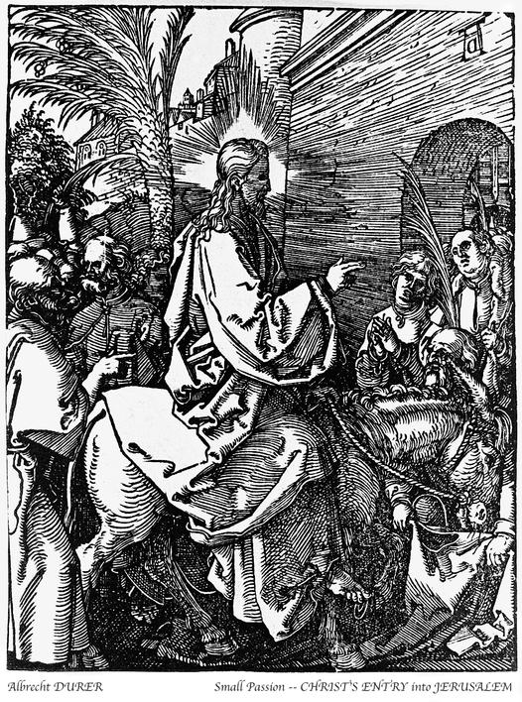 | 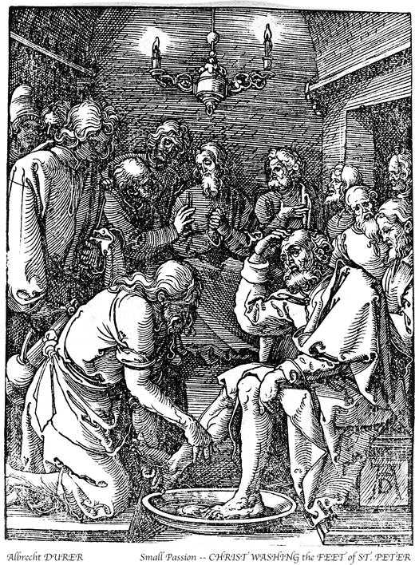
Jesus Enters Jerusalem Jesus Washes the Disciples’ Feet

THE HEART OF OUR FAITH
This is the most important week of the Christian Year.
Here we recall the events on which our entire faith
is based, the moments in history which bring us eternal salvation, reconciling the whole of creation to our loving creator,
redeemed through his own bitterly costly love.
For these eight days we enter a different mode of worship;
not just listening, watching, singing, but acting, participating bodily in the profound actions of this great week. Our services are by far the richest of the whole year, often complex and long. There are parts for the whole congregation to play, starting with the Palm Sunday procession in which we re-enact the joyful welcome the people of Jerusalem give to Jesus as he enters the Holy City. Overleaf we set out in detail the diary of services and what they signify.
Specific moments of participation include these below, see the notices by the south door, and SIGN UP!

* Maundy Thursday 7.00pm Eucharist
FEETWASHING

* Maundy Thursday 8.45-midnight
VIGIL BEFORE THE
ALTAR OF REPOSE

* Holy Saturday 10.00am – 12.30pm
THE EASTER PREPARATION:
CLEANING, POLISHING & BEAUTIFYING OUR CHURCH FOR EASTER

* Easter 5.00am Vigil, Ceremonies,
Baptism & First Eucharist
GRAND BREAKFAST TO END
THE LENTEN FAST IN TRUE
St MARY ABBOTS STYLE!

6.30 tonight 20th March  St JOHN  PASSION  J S Bach  Holy Week begins with this most profound meditation on  Jesus’ suffering and death.  St Mary Abbots’ professional soloists, choir, chorus & the Purcell orchestra | 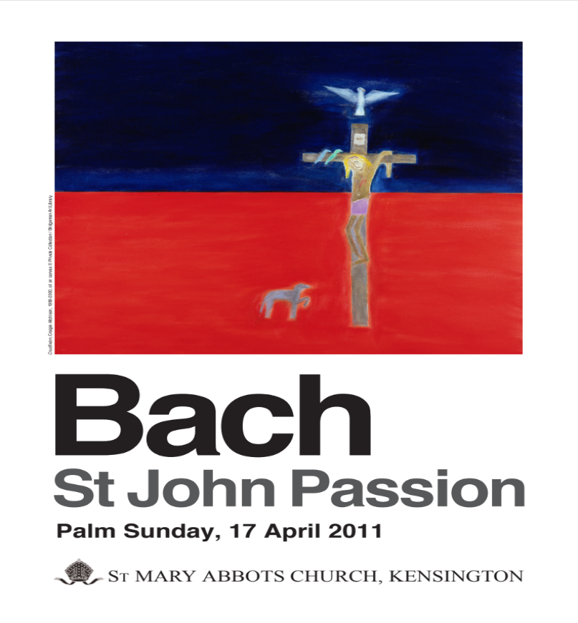
Tickets (£15) on sale at all morning services and at the door
Sunday 20th March PALM SUNDAY
8.00am HOLY EUCHARIST

starting in the Church Centre, Vicarage Gate:
9.00am PROCESSION OF PALMS leading to

9.30am SUNG EUCHARIST
with Sunday Groups
Gospel: THE PASSION ACCORDING LUKE
Collection to Bishop’s Lent Appeal – see over for details

11.15am CHORAL MATINS
Sermon: The Revd Jenny Petersen

12.30pm HOLY EUCHARIST

6.30pm ST JOHN PASSION – JS BACH

Monday 21st March HOLY MONDAY

At 9.00pm on these evenings the Vicar offers Devotional Addresses:
‘THREE OILS OF GLADNESS’:
then we sing the ancient office of Compline, (from the Latin for ‘completion’) a brief reflective service before rest at the day’s end.
8.30am Morning Prayer
1.05pm ‘Sunday on Monday’ HOLY EUCHARIST
5.30pm Evening Prayer
9.00pm THE OIL OF FORGIVENESS
Devotional Address; followed by Compline

Tuesday 22nd March HOLY TUESDAY
8.30am Morning Prayer
11.30am HOLY EUCHARIST Book of Common Prayer
5.30pm Evening Prayer
9.00pm THE OIL OF HEALING
Devotional Address; followed by Compline

Wednesday 23rd March HOLY WEDNESDAY
7.10am Morning Prayer
7.30am HOLY EUCHARIST
12.30pm Funeral: Hilda Knight Cooper RIP
5.30pm Evening Prayer
9.00pm THE OIL OF GLORY
Devotional Address; followed by Compline

Thursday 24th March MAUNDY THURSDAY
7.10am Morning Prayer
11.30am HOLY EUCHARIST Book of Common Prayer
1.30pm SUNG EUCHARIST - St Mary Abbots’ & St Barnabas & St Philips’ Schools Joint Holy Week Service
5.30pm Evening Prayer
7.00pm LITURGY OF THE LORD’S SUPPER
followed until midnight by
THE VIGIL OF GETHSEMANE

This is a service with two conflicting feelings:
rejoicing, because we are recalling firstly how Jesus broke bread and shared the wine, instituting the Holy Eucharist which sustains his church throughout the ages; and also
great sadness, as we remember his betrayal by those he loved. Bring bells, rattles & whistles to punctuate the Gloria, before the mood changes!
In obedience to Our Lord’s command, it includes the rite of feetwashing, showing how much we need God’s cleansing
We need more volunteers willing to have their feet washed – please sign the list in church.
After we have shared the Communion, remembering how Jesus led his disciples out to Gethsemane, consecrated Bread and Wine is carried in solemn procession to the Altar of Repose - a side altar bedecked with flowers. The rest of the church is solemnly stripped of all its decorations.
The Gethsemane Vigil is our opportunity to share Jesus’s desolation as he awaits betrayal and death, a solemn vigil of prayer and silence before the sacramental presence of Our Lord on the Altar of Repose. ‘Could ye not watch with me one brief hour?’ Sign the list in church to indicate when YOU will share in this vigil.
Friday 25th March GOOD FRIDAY
8.30am Morning Prayer & Litany
10.00am Children’s Good Friday Service
The Children’s Service is a short Passion Play processing inside & around the church, telling in drama, song & prayer Jesus’s suffering & death - families and children of all ages.

12noon PREACHING THE LORD’S PASSION
Last Words: Meditation on the Cross
The Revd Philip Welsh
Two hours’ meditation with addresses, hymns and silence.
You may come & go, joining & leaving this devotion if you wish

2.00pm GOOD FRIDAY LITURGY AND COMMUNION
This is the year’s most solemn service; austere, moving, beautiful. The choir sings to plainchant Our Lord’s Passion according to St John, we Venerate the Cross and pray the Solemn Intercessions. As we approach the moment of Jesus’s death we share the Communion – the Bread and Wine consecrated the day before.

Saturday 26th March HOLY SATURDAY
9.30am Morning Prayer & Litany
10.00am THE EASTER PREPARATION
EVERYONE, young and old, prepares the church to celebrate the Resurrection. We sweep & polish, spring cleaning throughout
& decorate with flowers: the children make the Easter Garden.

5.30pm Evening Prayer

REMEMBER TO PUT YOUR CLOCKS FORWARD ONE HOUR TONIGHT!
Sunday 27th March EASTER DAY
All Collections to Bishop’s Lent Appeal – see over for details

5.00am THE EASTER VIGIL, BAPTISM,
EASTER CEREMONIES AND
FIRST EUCHARIST OF EASTER
The year’s most complex, most wonderful – and longest – service. Originally a night long Vigil ending at dawn with the first Eucharist
of Easter, we keep it once again at 5.00am. It begins with readings from the Old Testament, retelling our salvation history. Then we move outside and light the New Fire, symbolising the Resurrection of Christ from the dead. The new Paschal or Easter Candle is lit from it and carried into the dark church. From it all the candles are lit and The Exultet, the Easter hymn of praise, is sung. We bless the baptismal waters and all renew our baptismal vows. Finally, the First Eucharist of Easter is celebrated, for Christ has risen from the dead and our Communion with him will never be broken. Bring bells, rattles & whistles to celebrate Christ rising from the Dead!
All who attend this service are invited to join us afterwards for a splendid ORGANIC FULL ENGLISH breakfast – please sign the list.

8.00am HOLY EUCHARIST
9.30am FAMILY EUCHARIST,
BAPTISMS & PROCESSION
Anthem: Blessed be the God and Father - WESLEY
The Easter Family Eucharist is led by our professional choir, includes a joyful procession to the font, baptisms and an all-age address (there’s a Group for the youngest children). It is the year’s most joyful service, and afterwards we continue the celebrations with drinks for the grown-ups and Easter eggs for the children.

11.15am SOLEMN MATINS
Motet: Surrexit Christus Hodie – SCHEIDT
Canticles: BRITTEN & HOWELLS
Anthem: Resurrexi - BYRD

12.30pm HOLY EUCHARIST

5.00pm FESTAL EVENSONG OF EASTER
AND HOLY EUCHARIST
Canticles: DYSON in D
Anthem: Surrexit pastor bonus - HASSLER

